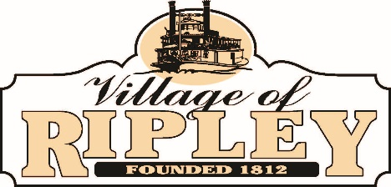

- Call to Order

- Pledge of Allegiance

- Roll Call

- Public Participation:

- General Business:
  - Approval of July 11 Council Minutes
  - Second Reading of Cemetery Levy
  - Discussion of Vacant Buildings Ordinance
  - Report from Greg Wilson
  - Report from Doug McDonald

- Staff Reports:
  - Fire Chief
  - Police Chief
  - Fiscal Officer
  - Solicitor
  - Administrator
  - Mayor
  - Council

- Executive Session pursuant to Ohio Revised Code Section 121.22(G) (2) of the Ohio Revised Code to consider the employment and/or compensation of a public employee and Ohio Revised Code Section 121.22(G) (3) Conferences with an attorney for the public body concerning disputes involving the public body that are the subject of pending or imminent court action

- Next Regularly Scheduled Council Meeting: August 8 at 6:30 PM
- Adjournment
Council Meeting Agenda
Tuesday, July 25, 2023
6:30 PM

