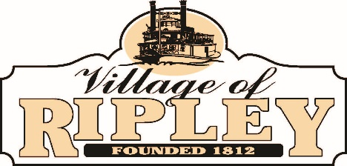

- Call to Order

- Pledge of Allegiance

- Roll Call

- Public Participation:

Roberta Jackson

- General Business:
  - Approval of May 23 Council Minutes
  - Reading of Weed Control and Litter Ordinance
  - Discussion of Boat Club Lease Payment
  - Report from Greg Wilson
  - Update on OHM Grant Application and public meeting
  - Update on dock project from Doug McDonald and Jeff Klump

- Staff Reports:
  - Fire Chief
  - Police Chief
  - Fiscal Officer
  - Solicitor
  - Administrator
  - Mayor
  - Council

- Next Regularly Scheduled Council Meeting: June 27 at 6:30 PM
- Adjournment
Council Meeting Agenda
Wednesday, June 15, 2023
7:00 PM

