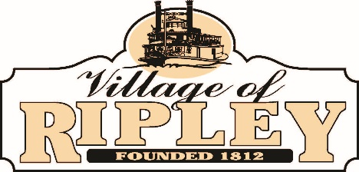

- Call to Order

- Pledge of Allegiance

- Roll Call

- Public Participation
Harriett Groh
- General Business:
  - OSU Business Survey Report
  - Approval of Minutes from March 28 and April 11 Council Meetings
  - Report from Greg Wilson
  - Report from Doug McDonald

- Staff Reports:
  - Fire Chief
  - Police Chief
  - Fiscal Officer
  - Solicitor
  - Administrator
  - Mayor
  - Council

- Next Regularly Scheduled Council Meeting: May 9 at 6:30 PM
- Adjournment
Council Meeting Agenda
Tuesday, April 25, 2023
6:30 PM

