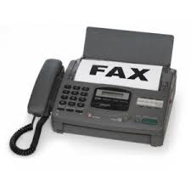
Village of Palmyra
Electronic Waste Event

Date: Saturday June 10, 2023

Time: 8:00 a.m. – Noon

Where: 430 Jefferson St.

Details: Must show proof that you’re a Village Resident.

Acceptable Items:

*Computers *DVD Players *Video Players
*VCR’s *Desktop printers *Computer monitors
*TV’s *Fax Machines *Cell Phones
*Tablets *Blue Ray *Router/Modems
*Keyboards & Mice *Video game consoles
*Scanners *Flash drives *External hard drives

(non-recyclable items per WI DNR: vacuums, lamps, CD Players, portable stereos/radios, fans, stereo speakers, ink/toner cartridges and any items made with wood) These items can be thrown in the trash

For More Information call 262-495-8316

