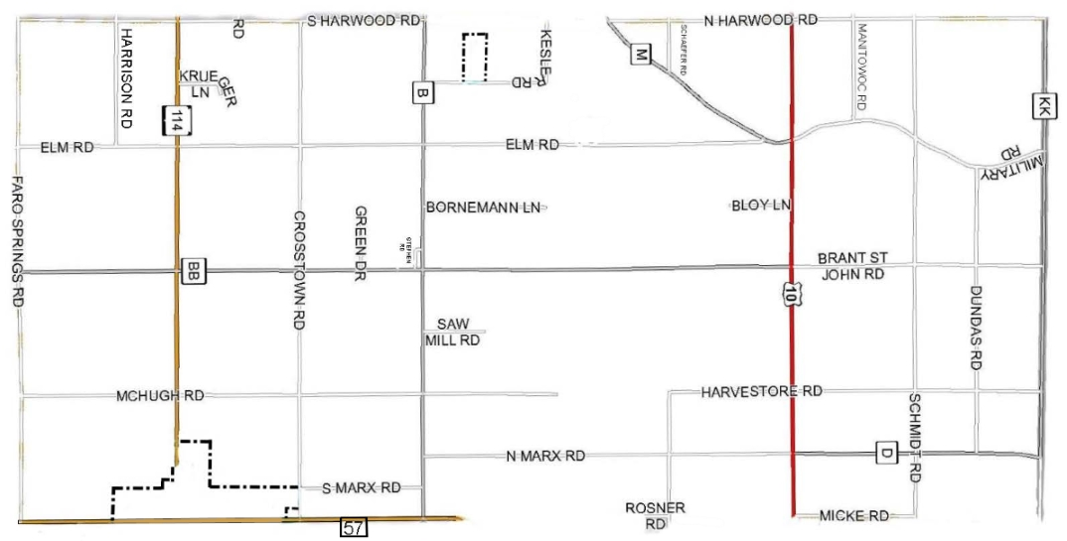
Manure Transfer Map

Please highlight which roads you will be using in theTown of Woodville

