2023 Jefferson County Spring Clean Sweep
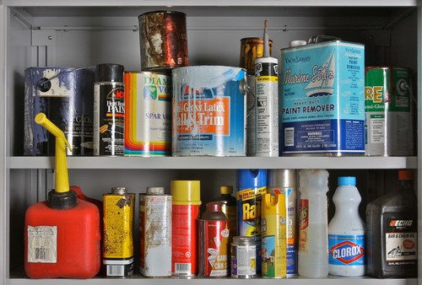
  - Jefferson County Fair Park (Gate 5, Spangler St.)
  - Household Hazardous Waste
Friday May 12 3:00 – 5:30 PM
Saturday May 13 8:00 – 11:00 AM
$10/Vehicle, Pre-Registration Required. Call (920) 674-7430 To Register.
Vehicle and Ag Tires
Fees Apply. Call (920) 674-7430 For Prices. Pre-Registration Not Required.
Electronics & Appliances – Saturday Only
Fees May Apply. Call (920) 674-7430 For Prices. Pre-Registration Not Required.

