NOTICE of PUBLIC HEARING, SPECIAL ELECTOR MEETING, and BUDGET SUMMARY
for the TOWN of HARRIS
Notice is hereby given that the Town of Harris, Marquette County, Wisconsin will hold a public hearing on the town's proposed 2025 budget on Monday, October 19, 2026 at 6:30 p.m., at the Town of Harris Firehouse Community Room, W4987 Cty Rd J, Westfield, WI. Immediately following the public hearing, there will be the Special Elector Meeting to vote on the total levy, and the regular Board of Supervisors Meeting will be held to approve the 2027 budget and any other business noted on the meeting agenda. The proposed budget is available for inspection on the town’s website at https://townofharriswi.com , attached to this notice and will be available at the meeting. The following is a summary of the proposed budget.
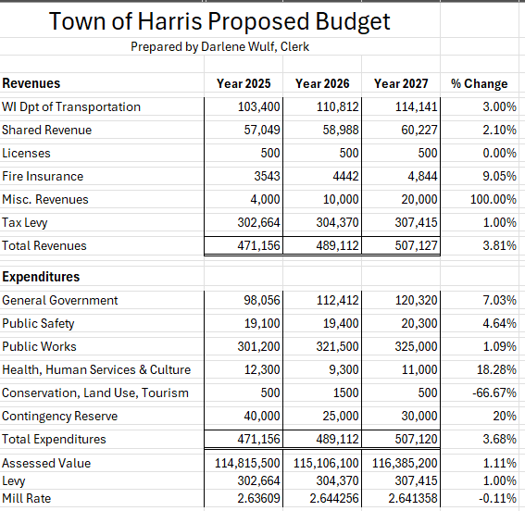
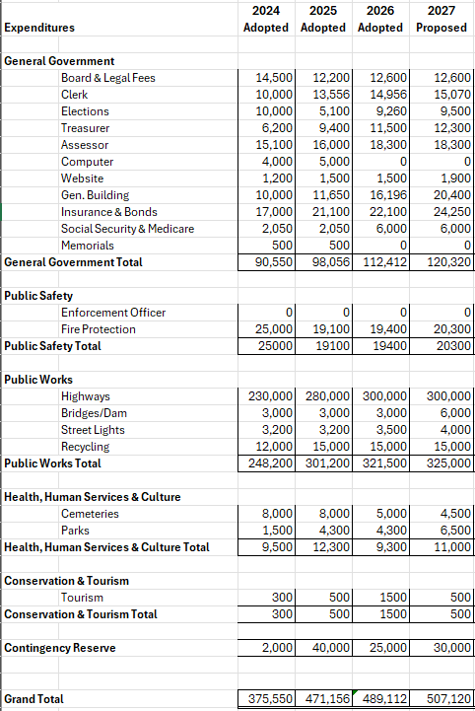

Bank Account Estimated Balances:
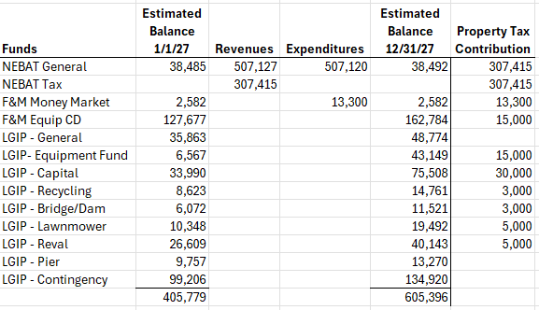
LGIP = Local Government Investment Pool

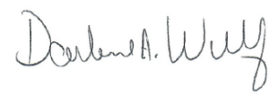
Posted this 1st day of October, 2026
By:
Darlene A. Wulf, Clerk

