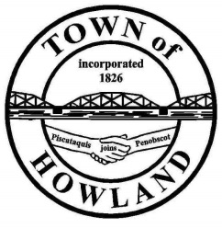
A G E N D A

HOWLAND BOARD OF SELECTBOARD MEETING
Selectpersons Meeting December 19th at 6PM
- Call the December 19, 2022 Town of Howland Selectboard Meeting to Order
- Pledge of Allegiance (Please Stand) MS to lead the Pledge
- Motion to accept the minutes from the December 12th 2022, selectperson’s meeting.
- Any changes to the agenda
- Public comment/questions (3-5 minutes) Please note these meetings are broadcast live unedited to our Facebook page.
- Old Business: NA
  - Main Street parking update
- New Business:
  - Discussion on the draft sex offender residency restriction ordinance. Once this has draft has been approved by the BOS I will forward this to our attorney for their review before placing it on the ballot in June 2023.
  - The Town office will be closing at 12 noon on 12/23 for our employee holiday party.
  - Discussion on having the BOS meetings start at 4PM for the months of Jan-April
  - I would like to welcome Hometown Energy & Nutrition to Howland they’re located at 70 Lagrange Road (old SOB Oil office). They specialize in protein shakes and energizing teas and fresh protein doughnuts/snacks.

- Manager’s Report
  - I have contacted Versant Power to cover the electric lines in the traffic circle as we are preparing to replace the light pole that was damaged due to a traffic accident last winter. Once the electrical lines have been covered, I will schedule the electrician and crane truck to place the new pole.
- Fire EMS update:
- Future Agenda Items.
- Adjourn

