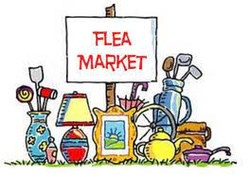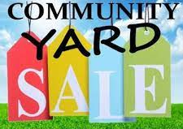
HOWLAND BARGAIN HUNTERS
FLEA MARKET & CRAFT SALE
COMMUNITY YARD SALE
July 17, 2021 8:00 AM TO 3:00 PM

Fee Proceeds Go To The Children’s Memorial At The Old Tannery Park
Flea Market & Craft Fair Spaces $10.00 for 16’Wx20’D
Flea Market & Craft Fair Items To Be Marketed Through Several Media Sources
Yard Sale Addresses, Sale Items & Hours And An Address Map To Be Marketed.

For Registration Forms/More Information
Email HowlandEvents.me@gmail.com, call 207-447-7277
Forms Can Also Be Picked Up At The Howland Town Office
REGISTRATION DEADLINE: SATURDAY, JULY 17, 2021
Check Out Howland Maine Community Events Facebook Page For Updates
(The earlier you register the more publicity you will get)

