BUILDING PERMIT REQUIREMENTS FOR DECKS

- Submit two copies of a tape location or instrument survey map of the property indicating the proposed location, distance to the property lot lines and any overhead wires.

- Submit two copies of the detailed construction drawing showing a cross section and the top view with footing depth, connection at house and deck height above grade indicate the size of joists and the distance between beams and house. Indicate size of the beams and distance between posts. Provide a detail of proposed guardrails, handrails, and stairs. Include an overview showing overall measurements beams and post approved flashing required at all points of attachment to the house.

- Please add the property address to all paperwork submitted.

- Provide an estimated cost of construction.

- If construction is being done by a contractor they must have general liability, work compensation and disability benefits insurance on file with the Town of Harrietstown before permit can be issued. Please call the Building and Planning Department with any questions.

- Check with your Building and Planning Department for the required setbacks for the property.

- Plan review is done by our staff prior to issuance of the building permit. After receiving the above information, this review is done in a first come first serve manner. We always try to expedite the review but planning ahead helps us all.

- At least 24 hours’ notice is required for inspections. Required inspections are noted on the building permit.

- Footers must be 60” inches deep and must be inspected before concrete is placed.

- A Certificate of Compliance (final inspection) is required on all deck permits. It is the responsibility of the homeowner to assure that ta final inspection has passed and a Certificate of Compliance has been issued.

- See the current Town of Harrietstown fee schedule at ceo@harrietstown.gov or visit Building and Planning Department Lower level of the Town Hall.

EXAMPLE DECK TOP VIEW
- Add beams as needed to fit your design.
- Fill in dimensions to fit your design
- Indicate the distance from the ground to the top of the deck.
- Deck can be free standing and not attached to the house this would require additional beams.

Ledger board with flashing and joist
HOUSE

?
?

max
1ft
max
1ft
?
?
?
?
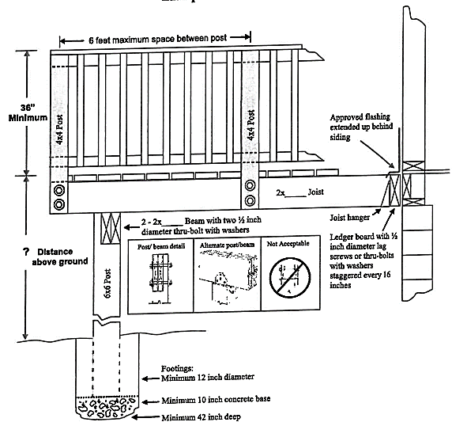
60
Indicate Connection Details
Post/Beam Detail Alternate Post/Beam NOT ACCEPTABLE
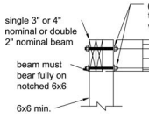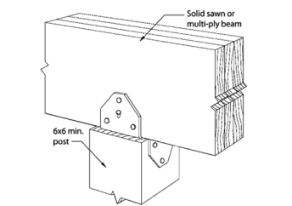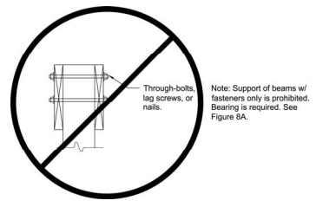

DECK BEAMS
Beam plies shall be fastened with two rows of 10d (3-inch × 0.128-inch) nails minimum at 16 inches (406 mm) on center along each edge. Beams shall be permitted to cantilever at each end up to one-fourth of the allowable beam span. Splices of multispan beams shall be located at interior post locations. The ends of each beam shall have not less than 1 ½ inches of bearing on wood or metal and not less than 3 inches on concrete or masonry for the entire width of the beam.

DECK BEAM SPAN LENGTHS (for supporting joist from side only)
SPECIES | SIZE | DECK JOIST SPAN LESS THAN OR EQUAL TO:  • (feet)
SPECIES | SIZE | 6’ | 8’ | 10’ | 12’ | 14’ | 16’ | 18’
Southern pine | 2 – 2 × 6 | 6-11” | 5-11” | 5-4” | 4-10” | 4-6” | 4-3” | 4-0”
Southern pine | 2 – 2 × 8 | 8-9 | 7-7 | 6-9 | 6-2 | 5-9 | 5-4 | 5-0
Southern pine | 2 – 2 × 10 | 10-4 | 9-0 | 8-0 | 7-4 | 6-9 | 6-4 | 6-0
Southern pine | 2 – 2 × 12 | 12-2 | 10-7 | 9-5 | 8-7 | 8-0 | 7-6 | 7-0
Southern pine | 3 – 2 × 6 | 8-2 | 7-5 | 6-8 | 6-1 | 5-8 | 5-3 | 5-0
Southern pine | 3 – 2 × 8 | 10-10 | 9-6 | 8-6 | 7-9 | 7-2 | 6-8 | 6-4
Southern pine | 3 – 2 × 10 | 13-0 | 11-3 | 10-0 | 9-2 | 8-6 | 7-11 | 7-6
Southern pine | 3 – 2 × 12 | 15-3 | 13-3 | 11-10 | 10-9 | 10-0 | 9-4 | 8-10

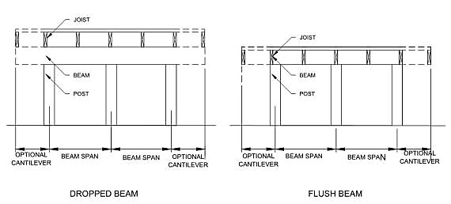

DECK JOIST AND DECK BEARING
The ends of beams shall have not less than 11/2 inches of bearing on wood or metal and not less than 3 inches of bearing on concrete or masonry for the entire width of the beam. Joist framing into the side of the ledger board or beam shall be supported by approval joist hanger. Joist bearing on a beam shall be connected to the beam to resist lateral displacement.

DECK JOIST SPANS FOR COMMON LUMBER SPECIES

SPECIES | SIZE | SPACING OF DECK JOIST WITH NO CANTILEVER |  |  | SPACING OF DECK JOIST WITH CANTILEVER
SPECIES | SIZE | 12” | 16” | 24” | 12” | 16” | 24”
SPAN FOR SOUTHERN PINE | 2x6 | 9’-11” | 9’-0” | 7’-7” | 6’-8” | 6’-8” | 6’-8”
SPAN FOR SOUTHERN PINE | 2x8 | 13’-1” | 11’-10” | 9’-8” | 10’-1” | 10’-1” | 9’-8”
SPAN FOR SOUTHERN PINE | 2x10 | 16’-2” | 14’-0” | 11’-5” | 14’-6” | 14’-0” | 11’-5”
SPAN FOR SOUTHERN PINE | 2x12 | 18’-0” | 16’-6” | 13’-6” | 18’-0” | 16’-6” | 13’-6”

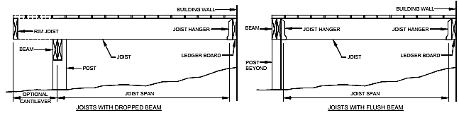

DECK POST TO BEAM CONNECTION
Deck beams shall be attached to deck posts and accordance with the following figure or by other equivalent means capable to resist lateral displacement. Manufactured pot-to-beam connectors shall be sized for the post and beam sizes. All bolts shall have washers under the head and nut.
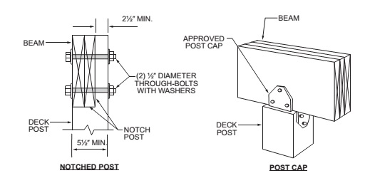

LEDGER DETAILS
Deck ledgers shall be a minimum 2-inch by 8-inch nominal, pressure-preservative-treated southern pine No. 2 grade or better lumber. Fasteners used in deck ledgers connections shall be hot dipped galvanized or stainless steel and shall be installed per the following details.

Deck ledgers shall not support concentrated loads from the beams or girders. Deck ledgers shall not be supported on stone or masonry veneer.

DECK LEDGER CONNECTION TO BAND JOIST
CONNECTION DETAILS | JOIST SPAN
CONNECTION DETAILS | 6′ and less | 6′1″ to 8′ | 8′1″ to 10′ | 10′1″ to 12′ | 12′1″ to 14′ | 14′1″ to 16′ | 16′1″ to 18′
CONNECTION DETAILS | On-center spacing of fasteners
1/2-inch diameter lag screw with 1/2-inch  • maximum sheathing. | 30” | 23” | 18” | 15” | 13” | 11” | 10”
1/2-inch diameter bolt with 1/2-inch maximum  • sheathing | 36” | 36” | 34” | 29” | 24” | 21” | 19”
1/2-inch diameter bolt with 1-inch maximum  • sheathing | 36” | 36” | 29” | 24” | 21” | 18” | 16”
- Ledgers shall be flashed in accordance with Section R703.4 to prevent water from contacting the house band joist.
- Snow load shall not be assumed to act concurrently with live load.
- The tip of the lag screw shall fully extend beyond the inside face of the band joist.
- Sheathing shall be wood structural panel or solid sawn lumber.
- Up to ¹/₂-inch thickness of stacked washers shall be permitted to substitute for up to ¹/₂ inch of allowable sheathing thickness where combined with wood structural panel or lumber sheathing.
PLACEMENT OF LAG SCREWS AND BOLTS IN DECK LEDGERS AND BAND JOISTS
MINIMUM END AND EDGE DISTANCES AND SPACING BETWEEN ROWS
 | TOP EDGE | BOTTOM EDGE | ENDS | ROW SPACING
Ledger a | 2 inches d | 3/4 inch | 2 inches b | 15/8 inches b
Band Joist c | 3/4 inch | 2 inches | 2 inches b | 15/8 inches b
- Lag screws or bolts shall be staggered from the top to the bottom along the horizontal run of the deck ledger in accordance with Figure R507.2.1(1).
- Maximum 5 inches.
- For engineered rim joists, the manufacturer’s recommendations shall govern.
- The minimum distance from bottom row of lag screws or bolts to the top edge of the ledger shall be in accordance with Figure R507.2.1(1).

SEE DETAILS ON NEXT PAGE

PLACEMENT OF LAG SCREWS AND BOLTS IN LEDGER
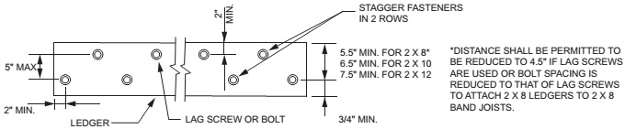
PLACEMENT OF LAG SCREW AND BOLTS IN BAND JOISTS PARALLEL TO HOUSE FLOOR JOIST
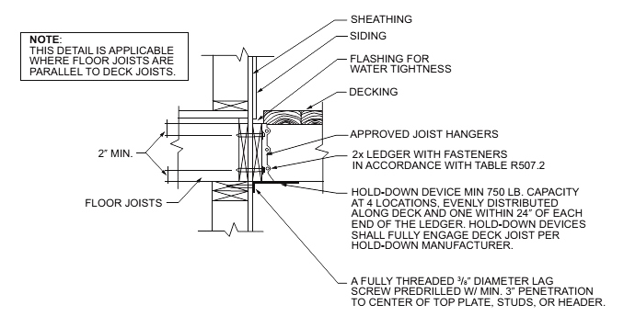
DECK ATTACHMENT FOR LATERAL LOADS
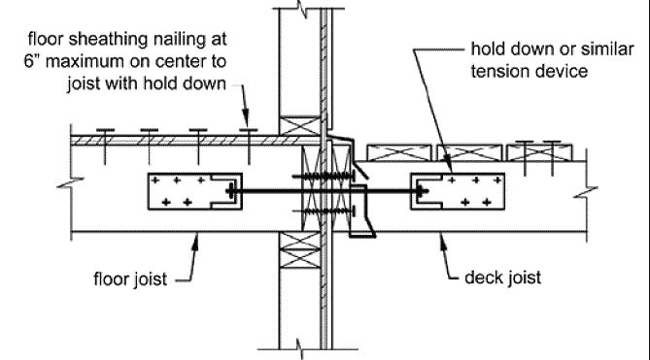

HANDRAIL AND GUARD FOR STAIRS DETAIL, TYPICAL
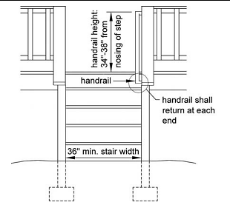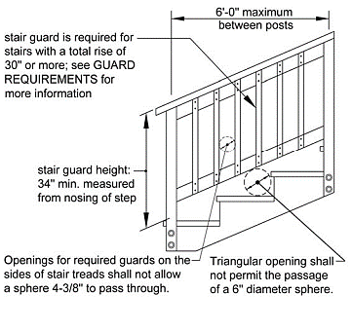
Openings in guards shall not allow the passage of 4 inch diameter sphere

GUARD DETAIL, TYPICAL

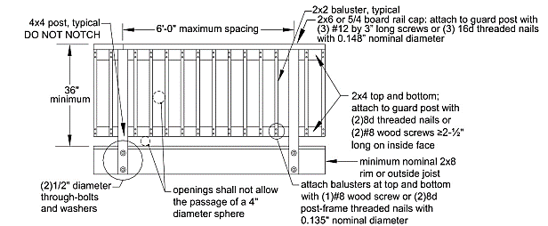

STAIR DETAILS, TYPICAL
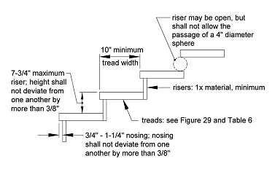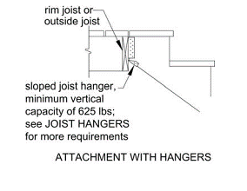
8-1/4”
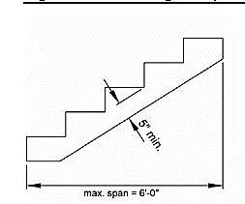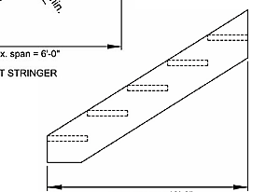
MAX SPAN = 6 FEET OTHER SPECIES

MAX SPAN = 7 FEET SOUTHERN PINE

MAX SPAN = 13;-3” OTHER SPECIES

MAX SPAN = 16’-6” SOUTHERN PINE

SOLID STRINGER
CUT STRINGER
