 | TOWN OF HARRIETSTOWN  39 MAIN STREET  SARANAC LAKE NY 12983

BUILDING PERMIT APPLICATION
- No person, firm or corporation shall commence the erection, construction, enlargement, alteration, removal, improvement, demolition, conversion or change in the nature of occupancy of any building or structure; or install plumbing or heating equipment; or cause the same to be done, without first having applied for and obtained a permit from the Enforcement Official of the Town.

- A permit shall not be required for the performance of ordinary repairs which are not structural in nature; however, any construction or repair work not requiring a building permit must nevertheless be done in conformance with the New York State Uniform Fire Prevention and Building Code 19 NYCRR, and any and all other State and local statutes.

- Amendments to the application, or the plans and specifications accompanying the same may be filed at any time prior to the completion of work, subject to the approval of the Code Official.

- A building permit shall be effective to authorize the commencing of work in accordance with the application, plans and specifications on which it is based, for a period of twelve (12) months after the date of its issuance. Work shall be substantially completed twelve (12) months after the start of the project. All work shall conform to the approved application, plans and specifications. For good cause, the Code Enforcement Officer may allow a maximum of two (2) extensions of the permit of one (1) year each, if seeing evidence that work is progressing. If the project cannot be completed within the allowed time period, additional extensions must be approved by the Town Board.

- The Code Enforcement Officer may revoke a permit where he finds:
- There has been any false statement or misrepresentations made as to a material fact in the application.
- The permit was issued in error and should not have been issued in accordance with applicable law.
- Work is not being performed in accordance with application provisions, plans or specifications.
- The person to whom a permit has been issued fails or refuses to comply with a Stop Work Order.

- The Code Enforcement Officer may issue a Stop Work Order whenever he has reasonable grounds to believe that such work is being performed in an unsafe and dangerous manner, or for any of the reasons stated in #5, or any other legally applicable reason.

- The Code Enforcement Officer and/or his agents may, upon the showing of proper credentials and in the discharge of his duties, enter the property, structure or premises for the purpose of inspection as provided in the Code, or for the investigation of a complaint.

- A Certificate of Occupancy is required upon completion of new home construction.

- A Certificate of Compliance may be required depending upon the nature of the project. The Code Official will make such a determination and may require certain tests in order to furnish said proof of compliance. All electrical work requires a third-party inspection prior to the issuance of a Certificate of Occupancy/Compliance.

- Responsibility for obtaining a building permit, daily inspections, and any necessary Certificates upon Completion shall be that of the Owner of Record.

PLEASE PRINT OR TYPE ALL INFORMATION BELOW ^{DATE _________________}
PROPERTY OWNER:________________________________________________________________________
MAILING ADDRESS: ___________________________________________________________
HOME:_______________________________________CELL:_________________________________________
EMAIL:_______________________________________________________________________________

APPLICANT (OTHER THAN OWNER)___________________________________________
MAILING ADDRESS:_______________________________________________________________
HOME PHONE:_______________________________CELL:___________________________________________
EMAIL:_______________________________________________________________________________________\
E-911 ADDRESS OF PROPERTY WHERE WORK IS BEING PERFORMED:
______________________________________ ____________________________ __________________
STREET ADDRESS CITY ZIP CODE

TAX IDENTIFICATION#__________________________LOT SIZE:_________________
BUILDING TO BE OCCUPIED AS: □ PRIVATE □ COMMERCIAL
IS THIS A CHANGE IN THE PRIMARY USE OF THE BUILDING? □ YES □ NO □ NEW
ESTIMATED COST OF CONSTRUCTION$____________________SQ. FOOTAGE:______
SETBACKS, MEASURED FROM FOUNDATION: FRONT YARD FT.
REAR YARD_________________FT. CLOSEST SIDE YARD____________FT.
TYPE OF CONSTRUCTION/DESCRIPTION (CHECK ALL THAT APPLIES)
BUILDING  - Single Dwelling  - Double Dwelling  - Duplex Dwelling  - Apartment Bldg.  - Condominium  - Town House  - Office Building  - Store  - Hotel  - Motel  - Factory  - Shop  - Church  - Garage  - Warehouse  - Storage  - Deck  - Addition  Other_______________ | CONSTRUCTION  - Concrete Block  - Frame Construction  - Brick  - Tile  - Steel  - Reinforced Concrete  Other_______________  EXTERIOR  - Siding  - Shingles  - Stucco  - Paper  - Aluminum  Other________________  ____# BEDROOMS | HEATING  - Oil Hot Water  - Hot Air/HVAC  - In Floor/Radiant  PLUMBING  Type__________________  - # Baths________  - # Toilets_______  - # Faucets ______  ROOF  - Shingles  - Slate  - Tile  - Gravel  - Board  - Metal  - Paper  - Other | BASEMENT  - Full Basement  - Half Basement  - Quarter Basement  - Floor  - Laundry  - Recreation Room  PORCHES  - # Porches_____  - # Of glass in___  - # Of Open_____  Other_____________  FUEL TYPE  - Propane/I.P  - Fuel Oil  DIMENSIONS  Overall___________________

BRIEFLY DESCRIBE THE WORK BEING DONE:

______________________________________________________________________________________________________________________________________________________________________________________________________________________________________________________________________________________________________________________________________________________________________________________________________________________________________________________________________________

PLANS AND SPECIFICATIONS MUST ACCOMPANY THIS APPLICATION
New York State laws require that all plans, drawings, and specifications relating to the construction or alteration of a building or structure which must be filed with a Building Code Official, must be stamped with the seal of an architect or professional engineer (N.Y. Educ. Law §7307 and Title 19 NYCRR Part 1203.3(a)(3Xl)).

Exemptions, Not Requiring an Architect's or Professional Engineers Stamp or Seal. The following exceptions do
not require the stamp or seal of a licensed, registered architect or professional engineer (N.Y. Educ. Law § 7307(5)):
- Farm buildings and other buildings used solely and directly for agricultural purposes.
- Single family residential buildings 1500 square feet or less, not including garages, carports, porches, cellars, or uninhabitable basements or attics.
- Alterations, costing $20,000 or less, if these alterations do not involve changes affecting the structural
safety or public safety of the building or structure

CONTRACTOR AND DESIGN PROFESSIONAL INFORMATION (IF APPLICABLE)
Contractors MUST provide a Certificate of insurance. naming the Town of Harrietstown as Certificate Holder. If the job does not require a contractor. The Affidavit of Exemption on Page 5 of this Application MUST be completed.

Architect or Engineer: _________________________________________________
Address ________________________________________Phone # ______________
General Contractor _________________________________________________
Address ________________________________________Phone # ______________
Electrical Contractor __________________________________________
Address ________________________________________Phone # ______________
Plumbing Contractor__________________________________________________
Address ________________________________________Phone # ______________

For any permit not required stamped plans per State Education Law, Sections 7307and 7209, please provide design plans for construction by either attaching 3- copies of the plan to this application or sketching a detailed diagram on the back of this page.

Please include the name of the street, correct distance from foundation to lot lines, including frontage (side and rear distances). Indicate where water supply and sewer lines are or will be located including distance apart, depth, etc. If construction is to be an addition to an existing building or an accessory building (garages, storage shed, etc.) indicate the size of current. building and (distance from foundation to lot lines or addition and/or accessory building.

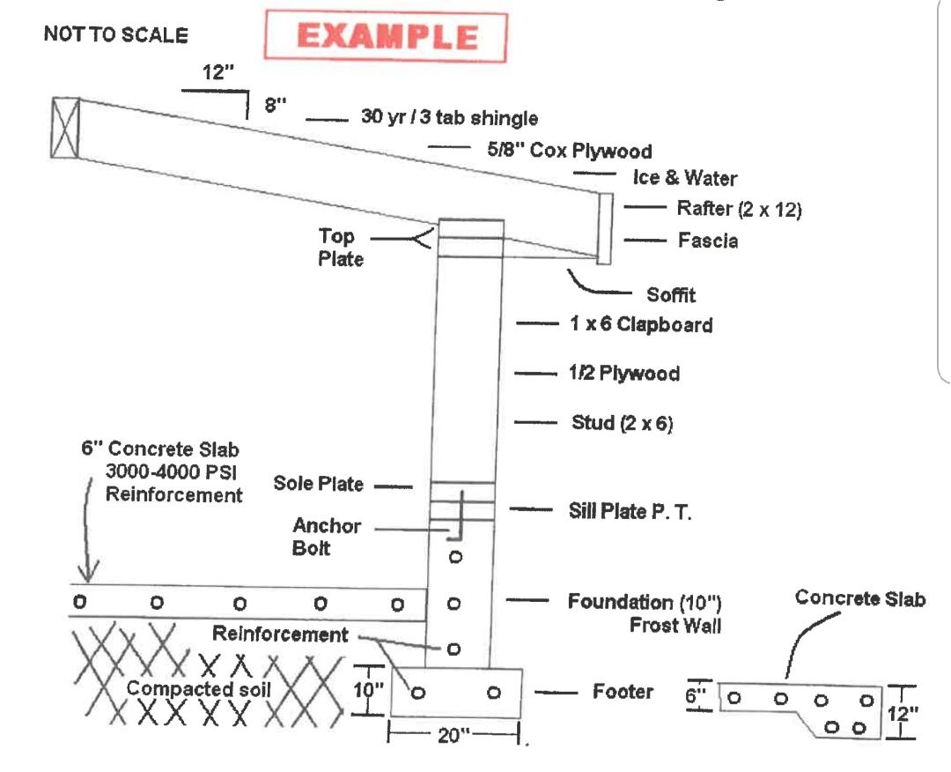

Layout with Setback

Elevation


Updated 8/4/2016

Development in the Adirondack Park - Potential State & Federal Permitting Agencies
In addition to local (town/village/county) building or subdivision permits, please be aware that you may also need a separate permit from one or more of the following states/federal agencies (this list may not be comprehensive).
It is the landowner’s responsibility to obtain the appropriate permits for a project.

NYS Adirondack Park Agency Jurisdictional Inquiry (JIF) Office PO Box 99  Ray Brook, NY 12977 (518) 891-4050  www.apa.ny.gov | NYS Department of Environmental Conservation  Regional Permit Administrator  DEC Region 5  Headquarters Warrensburg Office  PO Box 296 232 Golf Course Road Ray Brook, NY 12977 Warrensburg, NY 12885  (518) 897-1234 (518) 623-1282  (Clinton, Essex, Franklin, (Warren, Washington, Fulton, Hamilton Counties) Saratoga Counties)  DEC Region 6  (Herkimer, Jefferson, Lewis, Oneida, St. Lawrence Counties)  Region 6 Headquarters  317 Washington ST  Watertown, NY 13601  (315) 785-2245  DEC Permits may be needed for:  - Disturbance of bed or banks of streams, lakes, rivers (including bridges, boathouses, shoreline stabilization)  - Large wastewater systems  - Floating objects in navigable waters  - Public water supplies  - Stormwater discharge for construction sites of 1 acre or more  - Solid waste & hazardous waste disposal  - Other activities - please contact DEC
APA Permits/Approvals may be needed for:
- Construction of dwellings
- Subdivisions of land
- Activities in or affecting wetlands
- Change in use of certain buildings
- New commercial & industrial uses
- Towers & other structures over 40 feet in height
- Shoreline structures (including retaining walls)
- Waste disposal areas
- Other activities - please contact APA, ask for the Jurisdictional (JIF) Office
Department of Health
NYS DOH District Offices
Saranac Lake Glens Falls
(Essex, Franklin, Hamilton) (Saratoga, Warren, Washington)
(518) 891-1800 (518) 793-3893
Canton Herkimer Watertown (St. Lawrence) (Fulton, Herkimer) (Jefferson, Lewis) (315) 386-1040 (315) 866-6879 (315) 785-2277
County DOH Offices (administer NYS DOH jurisdiction)  Clinton County Oneida County DOH DOH  (518) 565-4870 (315) 798-5064 | US Army Corps of Engineers  Upstate NY Field Office Watervliet, NY (518) 266-6350
DOH Permits may be needed for:  - Septic systems  - Realty Subdivisions (5 or more lots, each lot 5 acres or less in size within any 3-year period)  - Shared (“community”) household water supplies  - Food service establishments  - Other activities - please contact DOH | - Structures in/over/under navigable US waters  - Discharge of dredged or fill material into US waters  - Other activities - please contact USACE
Other Potential Agencies*:
Lake George Park Commission
(Docks, moorings, marinas, stormwater in Lake George Basin)
(518) 668-9347
NYS Office of General Services
(Activities on submerged lands owned by NYS)
(518) 474-2195
Hudson River/Black River Regulating District
(Activities on land under the jurisdiction of the HRBRRD
i.e., docks & marinas on Sacandaga)
(518) 661-5535
NYS Department of Transportation
NYS DOT Regional Offices
Region 1 Office Region 2 Office Region 7 Office (Essex, Saratoga, (Fulton, Hamilton, (Clinton, Franklin, Warren, Herkimer) Jefferson, Lewis,
Washington) Utica, NY St. Lawrence) Albany, NY (315-793-2447) Watertown, NY (518) 457-3522 (315) 785-2333
DOT Permits may be needed for:  - Work in State Highway ROWs including new driveway access, underground & overhead utilities  - Other activities - please contact DOT | Office of Parks, Recreation and Historic Preservation  NY State Historic Preservation Office (518) 237-8643  *List may not be comprehensive

 New York State Department of Labor
Division of Safety and Health Gov. W. Averell Harriman State Office Building Campus Albany, NY 12240

Required Insurance

The only forms that are accepted as proof of Workers' Compensation Insurance are:
Form# Form Title
C-105.2 | Certificate of Workers' Compensation Insurance
CE-200 | Certificate of Attestation of Exemption - (no employees)
U-26.3 | State Insurance Fund Version of the C-105.2 form.
S1-12 | Certificate of Workers' Compensation Self-Insurance.
GSI-12 | Certificate of Group Workers' Compensation Self-Insurance.
GSI-105.2 | Certificate of Participation in Workers' Compensation Group Self-Insurance

For forms or general questions, contact the Workers' Compensation Board, Bureau of Compliance at (518) 486-6307. You can print forms from their website at www.wcb.state.ny.us.

New York State requires Disability Insurance if you are a "covered employer" as defined by New York State Law. The only forms that are accepted as proof of Disability Insurance are:
Form# Form Title
DB-120.1 | Certificate of Disability Benefit Insurance
DB-155 | Certificate of Disability Benefit Self-Insurance
CE-200 | Certificate of Attestation of Exemption-(no employees)

For forms or general questions, contact the Disability Benefits Bureau at (518) 486-6307.

We do not accept ACORD Farms as proof of insurance coverage.

You must use uniform and consistent Company or Entity names on all forms submitted.

All insurance forms submitted must show current coverage!
SH 439 (11-10

NOTICE OF UTILIZATION OF TRUSS TYPE CONSTRUCTION, PRE-ENGINEERED WOOD CONSTRUCTION AND/OR TIMBER CONSTRUCTION IN RESIDENTIAL STRUCTURES
{Ill accordance with Title 19 NYCRR PART 1265)
Town of Harrietstown Franklin County New York

TO: Todd David

OWNER OF PROPERTY: ______________________________________________________

SUBJECT PROPERTY (ADDRESS AND TAX MAP NUMBER):

________________________________________________________________________________

PLEASE TAKE NOTICE THAT THE (CHECK ALL THAT APPLY):
- New Residential Structure
- Addition to Existing Residential Structure
- Rehabilitation to Existing Residential Structure
TO BE CONSTRUCTED OR PERFORMED AT THE SUBJECT PROPERTY REFERENCE

ABOVE WILL UTILIZE(Check each applicable line):
- Truss Type Construction (TT)
- Pre-Engineered Wood Construction (PW)
- Timber Construction (TC)

IN THE FOLLOWING LOCATION(S) (CHECK APPLICABLE LINE):
- Floor Framing, Including Girders and Beams (F)
- Roof Framing ®
- Floor Framing and Roof Framing (FR)

SIGNATURE:________________________________________ DATE:___________________

PRINT NAME:________________________________________________

CAPACITY (Check One): □ Owner □ Owner's Representative

APPLICANT CERTIFICATION:
As owner or authorized representative of the building, structure, or land to which this permit applies, I agree to save the Town of Harrietstown harmless from any and all damages, judgements, costs, or expenses which said Town may incur or suffer by reason of the granting of this permit. I acknowledge that nothing contained herein, including the application and any approval herein granted for a project, shall be construed as an assertion of compliance with any requirements of the provisions of the Adirondack Park Agency Act or the Department of Health or the Department of Environmental Conservation of the State of New York Rules and Regulations. The Town of Harrietstown makes no representation pertaining to the applicant's compliance with any governmental laws, rules, or regulations other than the Building Code of the Town of Harrietstown and assumes no obligation for notification and coordination therewith. The Town of Harrietstown also makes no representation as to the existence of any other public right or the private rights of an individual or corporation with respect to a project.
________________________________________
Signature of Owner

IF THE OWNER'S SIGNATURE IS NOT PRESENT ABOVE, A SIGNED AUTHORIZATION MUST ACCOMPANY THIS APPLICATION.
AS APPLICANT, I hereby certify that the information contained in this application is correct and that I am aware of the requirements of the New York State Uniform Fire Prevention and Building Code and the Building and Zoning/Land Use Codes of the Town of Harrietstown.

________________________________________
Signature of Applicant (if different from owner)

OFFICE USE ONLY: ALL APPLICABLE FEES ARE NON-REFUNDABLE
I have reviewed this application and find it □ to be □ not to be in accordance with the provisions of the Building Code of The Town of Harrietstown and the New York State Uniform Fire Protection and Building Code 19 NYCRR, and this application is
□ approved □ not approved on this the __________ day of _________________, 20____.
If refused, reason: _________________________________________________________
_______________________________________________,Town of Harrietstown
Code Enforcement Officer

Building Permit #________________ Date Issuance____________
Building Permit Fee___________
Date of Payment_____________

Building Permit Fee for Residential Construction ( .20 per cubic foot,+ $40.00 base fee) f.t

Building Permit Fee for Commercial Construction ( .25 per cubic foot,+ $40.00 base fee) ft.

Other fees by Type ____________________________________________________________________
Description/Permit Type

DEC REQUIREMENTS FOR SMALL CONSTRUCTION PROJECTS
Did you know that if your project disturbs one or more acres of land, you MUST have a permit for storm water discharges from your site?
Why? Excessive amounts of sediment and debris from construction sites are often washed into local water bodies during a storm. Construction vehicles can leak fuel, oil and other harmful fluids that can be picked up by storm water as well.
What Under a new regulation, the Department of Environmental Conservation (DEC) requires that before?
To do? starting?
construction, a Stormwater Pollution Prevention Plan {SWPPP) must be developed. The SWPPP is a plan for erosion and sediment control, and for installation of treatment for post-construction runoff. Before construction activity begins, a Notice of Intent (NOi) must be filed with the DEC affirming that A SWPPP has been prepared and is being implemented. If you begin construction before filing that NOi and obtaining coverage, you may be subject to A penalty of up to $37,500 per violation, per day.
Think It could take up to sixty (60) business days to get a permit, but often only takes five (5) business days. The length of time depends on the type of construction site involved. It also depends on the existing levels of pollution in the water bodies to which storm water from the site will discharge.
For More Visit the website at: http://www.dec.ny.gov/ If you don't have web access, you can obtain written
Information material by calling 518-402-8265 Or call the DEC Regional Office at 518-897-1234.

STORMWATER REGULATIONS AND THE CONSTRUCTION INDUSTRY
Storm water Discharges: The construction industry is a critical participant in New York State's efforts to protect our streams, wetlands, rivers, bays, and lakes through the use of erosion and sediment control (ESC) practices. As storm water flows over a construction site, it picks up soil, debris, and chemicals and washes them into our water resources. The result is degraded water quality and aquatic habitat. Uncontrolled erosion can also have a significant financial impact on a construction project. It costs to:19riey and time to repair gullies, replace vegetation, clean sediment-clogged storm drains, replace poorly installed ESC practices, and repair damage to other people's property or to natural resources.
SOIL EROSION PREVENTION & SEDIMENT CONTROL, AN IMPORTANT RESPONSIBILITY ON ALL SITES
Minimize the area of exposed soil on site: To the extent possible, plan the project in stages to minimize area subject to erosion. The less soil exposed, the easier and cheaper it is to control erosion. Seed disturbed area immediately upon reaching finished grade. Seed or cover stockpiles that will not be used immediately
Protect defined channels with ESC practices adequate to handle expected storm flows: Use stabilizations; sod, geotextile, natural fiber, or riprap to allow channels to carry water without causing erosion. Use softer measures where possible.
Reduce velocity of Storm water: Use ESC practices such as vegetated buffers and check dams to slow down storm water as it travels across and away from the project site. Don't use silt fences or perimeter filters, and never install in streams or ditches.
Keep sediment on site: Maintain 50 feet of clean stone at all access points to accommodate large vehicles. Sweep the construction entrance road often to prevent seepage into storm drains. Do not hose paved areas. Use temporary sediment traps and basins with other permanent measures to retain sediment.
Divert clean water from disturbed soil: Use interceptors and diversion structures to direct flow away from exposed areas toward stable portions of the site.
Maintain all ESC practices to ensure their effectiveness during the life of the project: Regularly remove collected sediment from silt fences, berms, and traps. Maintain sediment controls that protect sensitive areas. Keep geotextiles and mulch in place until vegetation is well established.
- HOW TO BE IN COMPLIANCE
If your project will disturb one acre or more of ground, site owners and/or operators are required to:
- Develop a Stormwater Pollution Prevention Plan (SWPPP) and follow it
- Once a SWPPP is prepared, obtain a Storm water General Permit from DEC
- Certify, under penalty of law to follow that SWPPP
- Have a qualified professional perform inspections after ½ inch of rain, as well as weekly to determine compliance.
- Maintain erosion and sediment control practices and update the SWPPP regularly.
- Install permanent Stormwater Management Practices, as required by and in accordance with DEC Standards.
- Keep all SWPPP and Inspection forms in a logbook on the construction site and available to regulatory staff.

TOWN OF HARRIETSTOWN
BUILDING PERMIT APPLICATION
CHECKLIST

- Completed Page 2, Owner/Applicant, Property and Construction/Description Information

- Filled in Architect/Engineer & Contractor information - pg. 3 of the Application
and □ Not Applicable

- Briefly described the project being applied for, including dimensions.

- Attached 2 sets of project plans □ Not Applicable
- Engineered Plans □ Sketch Plan on back of pg. 4 □ Sketch Plan Attached

Error! Filename not specified.
Residential Compliance Checklist ECCCNYS-2010 □ Not Applicable

- Residential Compliance Checklist ECCCNYS-2010 □ Not Applicable

- Completed Notice of Utilization of Truss Type Construction, Pre-Engineered Wood
Construction in Residential Structures (Attached) □ Not Applicable

- Workers' Compensation and Liability Insurance Certificates from Contractors
or
- Completed, Signed and Notarized Affidavit of Exemption - pg. 5 of the Application

- Signed Applicant Certification - pg. 6 of the Application
or
- Included a signed authorization from the owner giving the applicant permission to
sign/act on their behalf.

- Other Attachments:
a.□____________________________________________________________________b.□___________________________________________________________________
c.□____________________________________________________________________

 | TOWN OF HARRIETSTOWN  39 MAIN STREET  SARANAC LAKE NY 12983

DAILY INSPECTION FORM

Code Enforcement Officer, Todd David

Office Phone: 518-891-0202 E-mail: ceo@harrietstown.gov
Cell Phone: 518-281-4622

** It is the responsibility of the property owner to notify**
The Building & Planning Department Twenty-Four (24) hours advance of all required inspections as shown on the building permit application.

Required Inspections Twenty-Four Hours' Notice is Required!
Site Inspection____________________ Water & Sewer____________________
Plumbing____________________ Insulation____________________
Foundation____________________ Framing____________________
Third Party Electrical____________________ HVAC ____________________
Final Inspection____________________
Comments___________________________________________________________________________
____________________________________________________________________________________

- All Individual Wastewater Treatment Systems and/or Repairs Before Covering Any Work
- Final Inspections Shall Be Performed Prior to a Certificate of Occupancy and/or Certificate of Compliance
- All Construction Shall Conform to the New Work State Uniform Fire Prevention and Building Code, the New York State Energy Code, and Land Use Code.
- Per Section 7.302, Article 47 of the New Work Sate Education Law. Building Plans submitted will bear the Seal and authorized signature of a New Work State Licensed Architect or Engineer.

This article shall not apply to residence buildings of gross area of fifteen hundred (1500) square feet or less (exterior dimensions) nor alterations to any building or structure costing ten thousand dollars ($10,000.00) or less which does not involve changes affecting the structural stability and/or public safety thereof.

