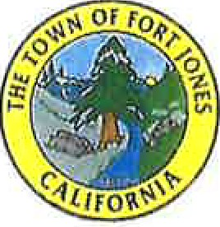

AGENDA
Special Meeting

Monday December 22, 2025 @ 9:00am
Town Hall
11960 East Street Fort Jones, CA 96032

CALL TO ORDER:

Fort Jones Town Council Roll Call:

Members: DeAndreis DeCausmaker Garcia Johnson LaRiviere

PLEDGE OF ALLEGIANCE: Led by Mayor

PUBLIC COMMENTS:
Any person may address the Council at this time regarding the subject matter of any item on this special meeting agenda only. There is a three (3) minute limit per person.

CLOSED SESSION:
The Town Council will recess to Closed Session to discuss the below item(s). At the conclusion of the Closed Session, Open Session will be reconvened and reportable action, if any, will be announced. Announcement of any action taken by the City Council in Closed Session required by the Ralph M. Brown Act (Government Code § 54950 et. seq.).

A. Public Employee Employment Appointment, Evaluation: (Gov. Code §54957(b)(1) Position: Town Administrator

REPORT ON CLOSED SESSION

OPEN SESSION:
A. Review and possibly approve resolution amending time change of regular council meetings for 2026.

ADJOURNMENT:
The next Fort Jones Town Council Meeting is scheduled to be held on January 12, 2025 at 7:00 p.m.

It is the intention of the Town of Fort Jones to comply with the Americans with DisabilitiesAct (ADA) in all respects. If, as an attendee or a participant at this meeting, or in meetings on a regular basis, you will need special assistance beyond what is normally provided, the Town will attempt to accommodate you in every reasonable manner. Individuals who need auxiliary aids or services for effective communication or to participate in programs and services of the Town of Fort Jones are invited to make their needs and preferences known by contacting the City Hall office, (530) 468-2281, at least 72 hours prior to the meeting.

Town of Fort Jones• 11960 East Street• Fort Jones, CA 96032 • s30 468-2281

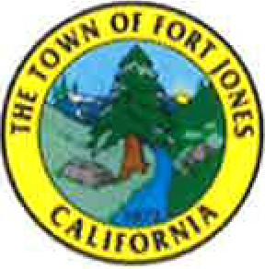

RESOLUTION NO.

A RESOLUTION OF THE TOWN COUNCIL OF THE TOWN OF FORT JONES AMENDING THE REGULAR TOWN COUNCIL MEETING TIME FOR CALENDAR YEAR 2026

WHEREAS, Section 2.04.0l0(a) of the Fort Jones Municipal Code establishes that the Town Council shall hold regular meetings on the second Monday of each month at the hour of 7:00 p.m., unless otherwise specified by the Town Council; and
WHEREAS, Section 2.04.0l0(c) of the Fort Jones Municipal Code authorizes the Town Council to specify changes to its regular meeting dates and times for each calendar year by resolution adopted in November or December of the prior calendar year; and
WHEREAS, the Town Council desires to amend the regular meeting time for calendar year 2026 to improve accessibility, efficiency, and public participation in Town Council meetings.

NOW, THEREFORE, IT IS RESOLVED:
- For calendar year 2026, the regular meetings of the Fort Jones Town Council shall be held on the second Monday of each month at 6:00 p.m.
- Except as expressly amended by this Resolution, all other provisions of Fort Jones Municipal Code Section
2.04.010 shall remain in full force and effect.
PASSED AND ADOPTED by the Town Council of the Town of Fort Jones on the 22nd day of December, 2025, by the following vote:
AYES:
NOES:
ABSENT:
ABSTAIN:

APPROVED:
ATTEST:
Madeleine DeAndreis, Mayor
Corinne Guidi, Town Clerk
11960 East Street• P.O. Box 40 • Fort Jones, CA 96032 • 530 468-2281

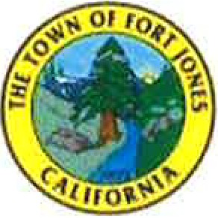

'Tfie cfown of Port Jones

To:
Meeting Date: From: Subject:
Fort Jones Town Council December 22nd 2025
Joseph Hess - Interim Town Administrator
Review and Approve Resolution Amending Regular Meeting Times for 2026

Background

Section 2.04.010 of the Fort Jones Municipal Code establishes that regular Town Council meetings are held on the second Monday of each month at 7:00 p.m., unless otherwise specified by the Council. The Municipal Code further authorizes the Town Council to modify its regular meeting dates and times for a specific calendar year by resolution adopted in November or December of the preceding year.

At this time, the Town Council is considering amending the regular meeting start time for calendar year 2026 from 7:00 p.m. to 6:00 p.m. The proposed resolution applies only to the 2026 calendar year and does not permanently amend the Municipal Code.

Recommendation
The Interim Town Administrator recommends that the council review the proposed resolution and take action on it.

