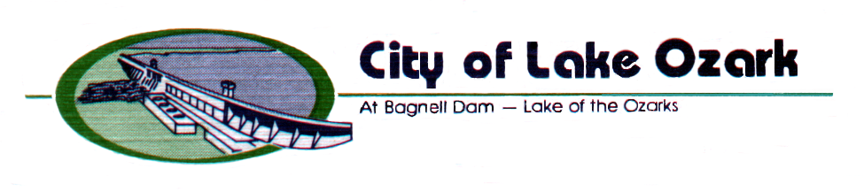
3162 Bagnell Dam Blvd.
Lake Ozark, MO 65049
573/365-5378 FAX 573/365-4515
www.cityoflakeozark.net

NOTICE OF WORK SESSION MEETING

Lake Ozark Board of Aldermen

March 3, 2023 @ 9:00 am.

Lake Ozark City Hall

CALL TO ORDER

ROLL CALL

APPROVAL OF AGENDA

ITEMS OF DISCUSSION

- Discussion regarding citywide goals and priorities

- Discussion regarding the Highway Safety & Traffic Division of the Missouri Department of Transportation – Spring DWI Enforcement Campaign

- Discussion regarding the possible location of time capsules at the roadside park

ADJOURNMENT

If any member of the public requires a specific accommodation as address by the American with Disabilities Act, please contact the City Clerk’s office 48 hours in advance of the meeting at the telephone number above.

